3-2 Activity: GNS3 Sandboxing Part Two
Andree Salvo
Southern New Hampshire University
Cyb 220
Instructor: Wesley Buchan
2025

CYB 220 3-2 Activity: GNS3 Sandboxing Part Two

You are provided with a GNS3 environment that has a virtual PC that you are asked to harden. The group policy settings you need to change are listed in the table below. Fill out the Path to GPO Setting column in the table below. Use the Windows 10 and Windows Server 2016 Policy Settings spreadsheet to search for the specific settings that need to be modified. The information in Column D and Column E will help you identify the path to the GPO setting.

For example, the GPO path for the policy setting “Hide the 'Add programs from Microsoft' option” can be found with the following steps:

- Identify the Scope: The policy's scope is indicated in Column D. In this case, it is "User," which means it affects user settings.
- Locate the Policy Path: In Column E, you find the specific path where the policy is located: “Control Panel\Add or Remove Programs.”
- Combine the Components: Since this policy is part of an Administrative Template, you construct the full GPO path by starting with the user configuration section and appending the policy path:
- Full GPO Path: User Configuration\Administrative Templates\Control Panel\Add or Remove Programs

Group Policy Name | Path to GPO Setting
Hide specified Control Panel items (hide user accounts) | 1. User Configuration  2. Administrative Templates  3. Control Panel  4. Hide specified Control Panel Items  Full GPO path: User Configuration\ Administrative Template\Control Panel
Remove Task Manager | 1.User Configuration  2.Administrative Template  3.System  4.CTRL+ALT+DEL  Full GPO path: User Configuration\Administrative Template\System\Ctrl+ALT+DEL
Remove Recycle Bin icon from desktop | 1.User Configuration  2.Administrative Template  3. Desktop  4.Remove Recycle Bin icon from desktop  Full GPO path: User Configuration\Administrative Template\Desktop
Disable delete notifications on all volumes | 1.Computer Configuration  2. Administrative Template  3. System  4.FileSystem  Full GPO path: Computer Configuration\Administrative Template\System\FileSystem
Turn off printing over HTTP | 1.User Configuration  2.Administrative Template  3. System  4. Internet Communication Management  5. Internet Communication Settings  Full GPO path: User Configuration\Administrative Template\System\Internet Communication Management\Internet Communication Settings
Turn on menu bar by default | 1.User Configuration  2.Administrative Template  3.Windows Components  4.Internet Explorer  Full GPO path: User Configuration\Administrative Template\Windows Components\Internet Explorer

When you have filled out the table, insert screenshots below for each changed setting within the GPO.

  - Hide Specified Control panel items (hide user accounts)
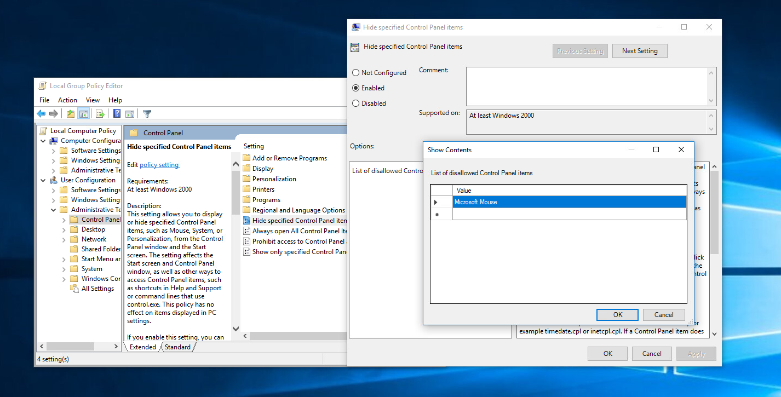

  - Remove Task Manager
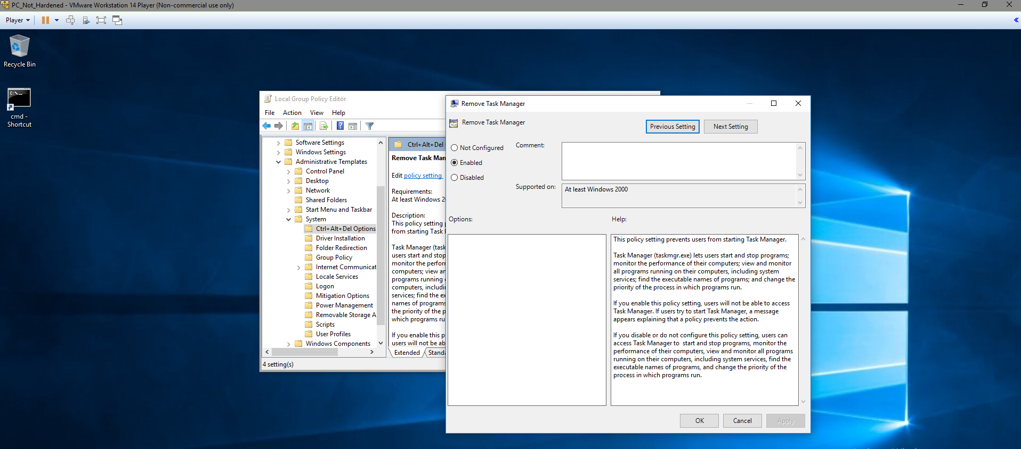

  - Remove Recycle Bin icon from desktop
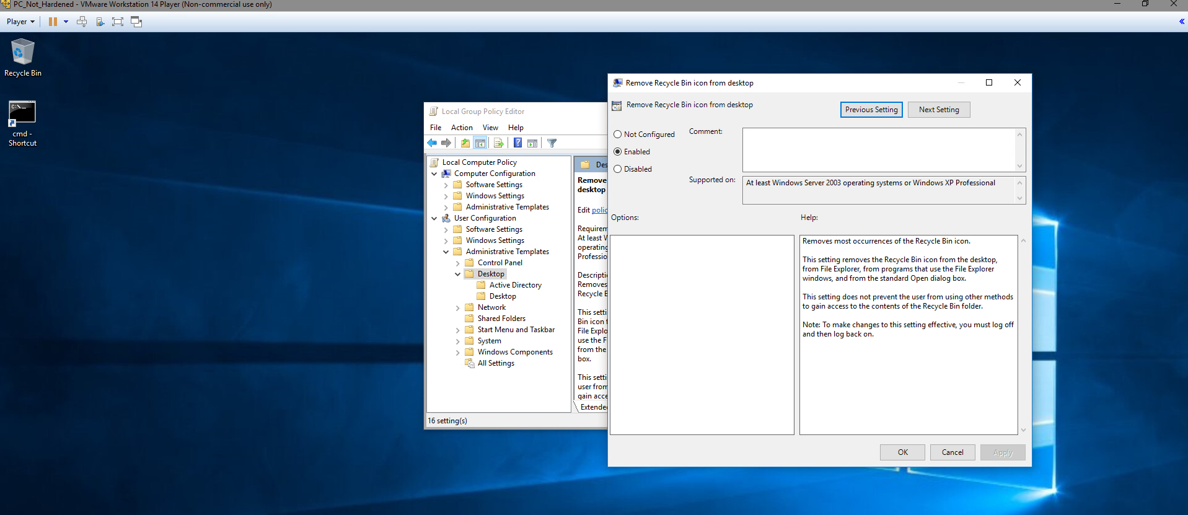

  - Disable delete notifications on all volumes
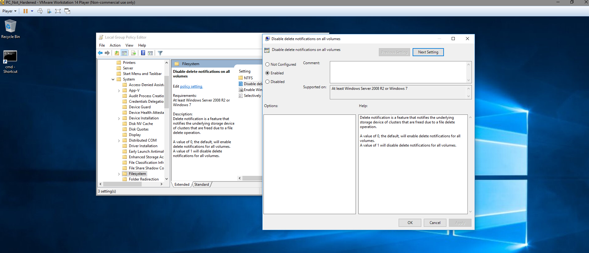

  - Turn off printing over HTTP
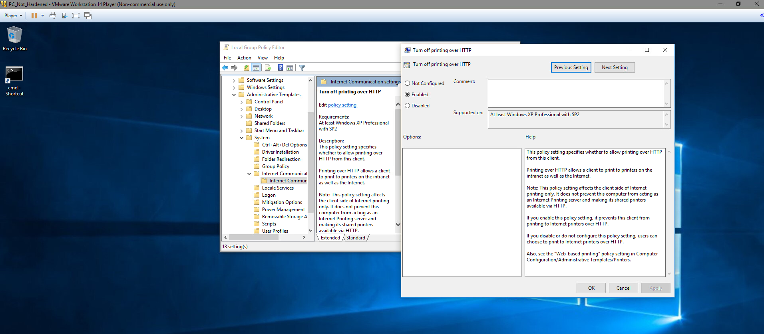

  - Turn on menu bar by default
